**Task 1:**

Data Quality Assessment **-** Assessment of data quality and completeness in preparation for analysis.

Start with the preliminary data exploration and identify ways to improve the quality of data. Assess the quality of their data; as well as make recommendations on ways to clean the underlying data and mitigate these issues.

Datasets provided:

* Customer Demographic
* Customer Addresses
* Transactions data in the past 3 months

**Data Quality Framework Table :** Below is a list of the Data Quality dimensions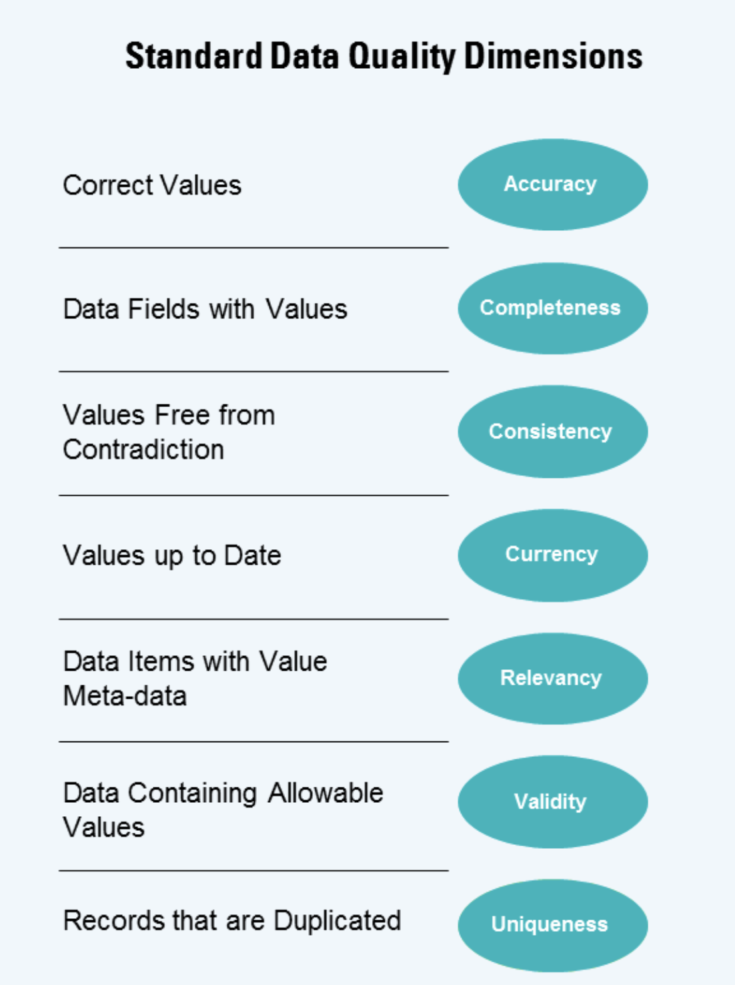

**Task 2 :**

Data Insights : Targeting high value customers based on customer demographics and attributes.

Analysing their existing customer dataset to determine customer trends and behaviour. And which of these 1000 new customers should be targeted to drive the most value for the organisation.

Prepare a detailed approach for completing the analysis including activities a detailed approach for completing the analysis including activities – i.e. understanding the data distributions, feature engineering, data transformations, modelling, results interpretation and reporting.

# 

# 